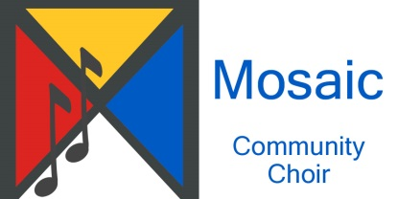**Mosaic Community Choir Incorporated** - **Membership Registration form**

**First name** ……………………………………………… **Surname** ………………………………………………

**Preferred name (***if different from formal name*) …………………………………………………..

**Residential address and postcode** ………………………………………………………………………………………………………………

**Email address**……………………………………………………………………………………………………………………………………………….

**Preferred phone number(s**) …………………………………………………………………………………………………………………………

**Emergency contact details: ………………………………………………………………………………………………………………….…..**

**Do you consent to your email address and phone number(s) being made available for a group contact list for the use of choir members only? Yes / No**

**Do you consent to the use of your photo to promote or publicise the choir's activities in print, electronic or other media? Yes / No**

**Have you previously sung with a choir?** ……………………………………………………………………………………………………..

**What is your preferred singing part or register?**

(Soprano, alto, tenor, baritone, bass, don’t know) ………………………………………………………………………….............

**Can you sing other parts?** (Please list) ………………………………………………………………………………………………………..

**Can you read music? (***Note this is not mandatory***)** ……………………………………………………………………………………….

**Can you play a musical instrument?** (Please list) ……………………………………………………………………………………….

dancing notes

**I wish to become a member of Mosaic Community Choir Inc. I have read and will abide by the** [**Rules of Association**](Mosaic%20Community%20Choir%20Rules%20of%20Association%20(1).pdf)

**Date (of application)** …………………………………………………. **Signature** ……………………………………………………………….

**Name and Signature of two Committee Members\***

1. …………………………………………………………………………………………………………. **Date** …………………………………..…....
2. …………………………………………………………………………………………………………. **Date** …………………………………………..

*Under the Rules of Association, new members must be nominated by two members of the Mosaic Choir Committee, unless this responsibility has been delegated to two ordinary choir members.

**Date of membership confirmation at Committee Meeting** ………………………..…………………….……………………….

Mosaic Community Choir Incorporated Registration No. A0057495A Form revised 25/7/2023

www.**mosaicchoir**.org.au/